

Project Report on

**DIU Transport Service Mobile Application**

**Course Code:**CSE316

**Course Title:**Software Project III

**Submitted To**

Mr. Md.Mahbubur Rahman

Department of CSE

Daffodil International University

**Submitted By**

Mst.Habiba Sultana

ID:221-15-5528

Section:61-Q

Department of CSE

Daffodil International University

**Project Title:** DIU Transport Service Mobile Application.

**Project Principle:** This report presents the development plan for a mobile application, "DIU Transport Service," designed to address transportation challenges faced by students at Daffodil International University (DIU). The app offers on-demand ride booking, real-time tracking, and a variety of transportation options, catering specifically to the needs of the DIU student body.

**Problem and Opportunity:**

Traditional transportation methods around the DIU campus often present inconveniences for students, including long wait times, unreliable schedules, and limited route options.

This project identifies an opportunity to streamline student commutes by developing a mobile application that provides:

1)Enhanced Convenience: On-demand booking eliminates waiting, while real-time tracking allows users to plan their travel efficiently.

2)Flexibility: A variety of transportation options caters to different preferences and urgency levels.

3)Transparency: Clear fare estimates ensure cost predictability before booking.

**Target Audience:**

The primary target audience for DIU Transport Service is the student population of Daffodil International University. The app caters to students seeking a convenient, reliable, and efficient on-campus and surrounding area transportation solution.

**Project Architecture Patterns:**

Overall, reusable solutions to frequently occurring issues in software design are known as architectural patterns. They have a significant effect on the codebase. We deploy two architectural patterns in our proposal.

**MVC Pattern**: In the DIU Transport Project, the MVC architecture utilizes MySQL for data storage and Hibernate for managing data and business logic in the Model layer. The View layer employs HTML/CSS/JavaScript and EJS to create responsive user interfaces. Controllers in Express.js/Spring MVC handle user input, routing, validation, and session management. Integration, testing, and deployment ensure a cohesive and scalable application, fostering maintainability and collaboration among developers while ensuring data integrity and security.

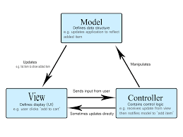

**MVP Pattern:**

The MVP pattern is a UI presentation approach based on the MVC pattern's ideas. It just prescribes the view's organization. First, rendering UI components is the responsibility of the view. Second, the presenter is loosely coupled to its view through the use of the view interface.

Creating an architecture for a Minimum Viable Product (MVP) for a DIU (Daffodil International University) transport project involves several key components. The goal is to develop a system that manages and optimizes transportation services for the university community. The architecture should be scalable, secure, and efficient, focusing on core functionalities that can later be expanded.

* 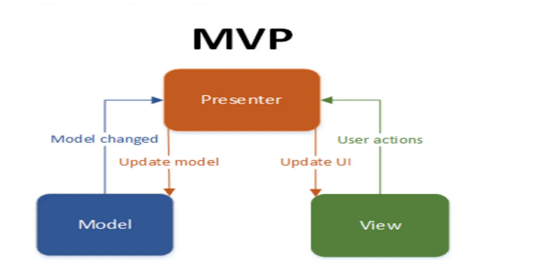

**DIU Transport Planning and requirments:**

I’m going to continue with the project based on the MVP architecture because all that is required of us in this one is UI design. Here, I will design my user interface's presentation layer and assign responsibilities to each UI component. Additionally, the user interface will be demonstrated, and its responsibilities and logic will be developed by the software's activity.

**Key Features for the MVP:**

* User Registration and Authentication: Allow students, staff, and drivers to register and log in.
* Bus Scheduling: Manage and view bus schedules.
* Booking and Reservations: Enable users to book seats on buses.
* Notifications**:** Send alerts and notifications for bus schedules and updates.
* Route Management**:** Manage bus routes.
* Admin Panel**:** Admin functionalities for managing users, schedules, and routes.
* GPS Tracking: Basic GPS tracking of buses.

**Technology Stack:**

The development process will average strong technology stack to ensure optimal performance, scalability, and user experience.

**Development Tools, Method & Environment Explanation:**

**Mobile App Development:**

Framework: React Native, Flutter

The user interface students interact mobile App (Flutter/React Native)

* Schedule Screen
* Booking Screen
* Login/Register Screen
* Notifications Screen
* Profile Screen

Design & Development Tools: Industry-standard UI/UX design tools (e.g., Figma, Adobe XD) combined with framework-specific development tools (e.g., React Native CLI, Flutter DevTools).

Database: Flexible NoSQL database (e.g., MongoDB) for efficient user data, location information, and ride detail management.

* Users Table,Buses Table
* Schedules Table
* Bookings Table
* Routes Table

Mapping Service: Integration with a leading mapping service (e.g., Google Maps API) for real-time location tracking and optimized route planning.

Development Timeline: Generally, the development process can be broken down into phases:

Phase 1: Front-end Development (Estimated duration)

Phase 2: Back-end Development (Estimated duration)

Phase 3: Integration and Testing (Estimated duration)

Also,I will use Figma software to design the app’s UI and for development will use JavaScript programming language with React as a framework. Moreover, the code of the website will be uploaded to GitHub.

**Project justification:**

The DIU Transport Service aims to transform student commutes with features like secure authentication, real-time tracking, transparent fare estimation, secure payment integration, and a feedback system. By offering convenience, reliability, and efficiency, it has the potential to significantly enhance student life at Daffodil International University. Leveraging a strong technology stack and user-centered design, the app empowers students with control over their commutes, enriching the overall university experience.

**Future Features and Development of the Project:** I have big plans for this project in the future and after launching this project I will slowly move forward with its new features and development. Future upgrades for DIU Transport may involve smarter routes, more payment options, and predictive maintenance for better management. These advances aim to make student commutes smoother, enhance service efficiency, and maintain a seamless transportation experience at Daffodil International University.